Durga Prasanna Kumar
2300031112cseh2@gmail.com

SPRING CORE AND MAVEN –
STEP -1 CREATE BOOKSERVICE.JAVA
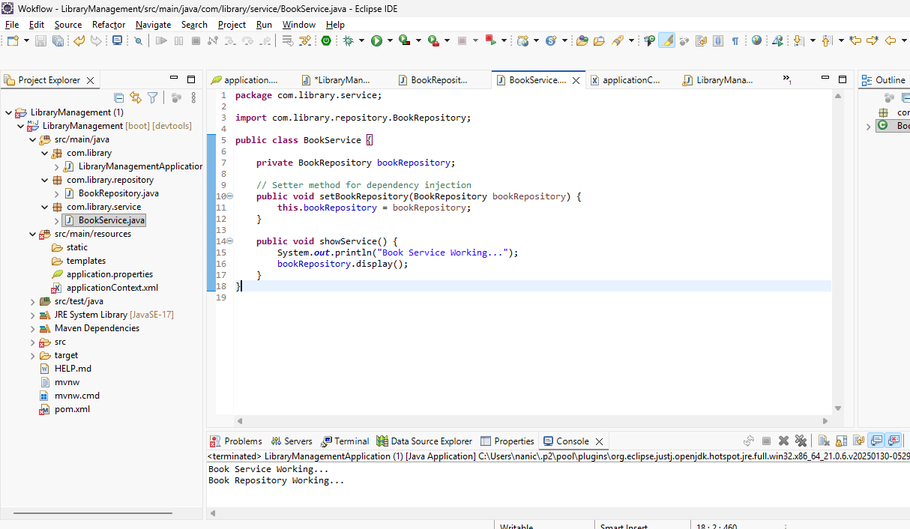

STEP -2 BOOKREPOSITORY.JAVA
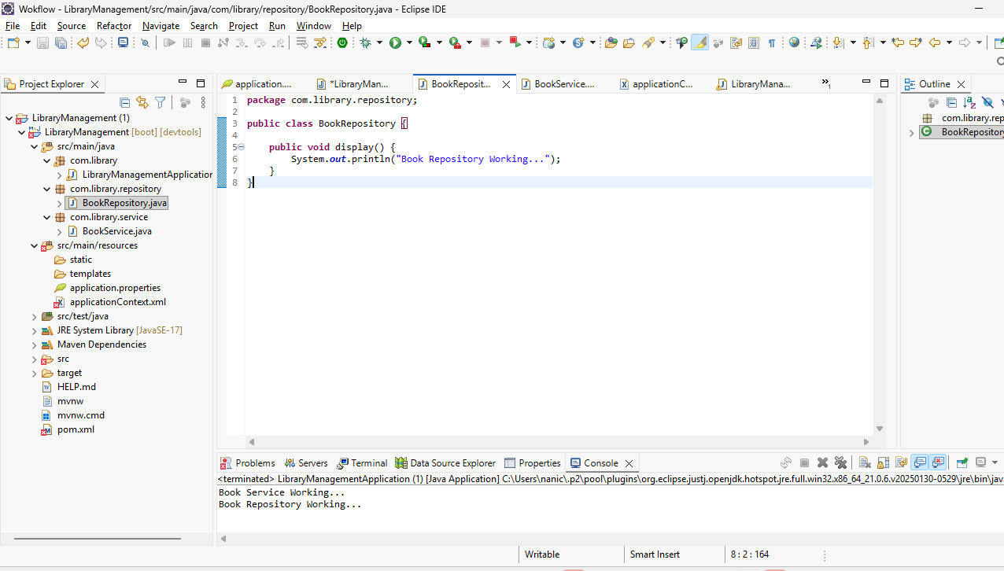

STEP – 3-MAIN CLASS
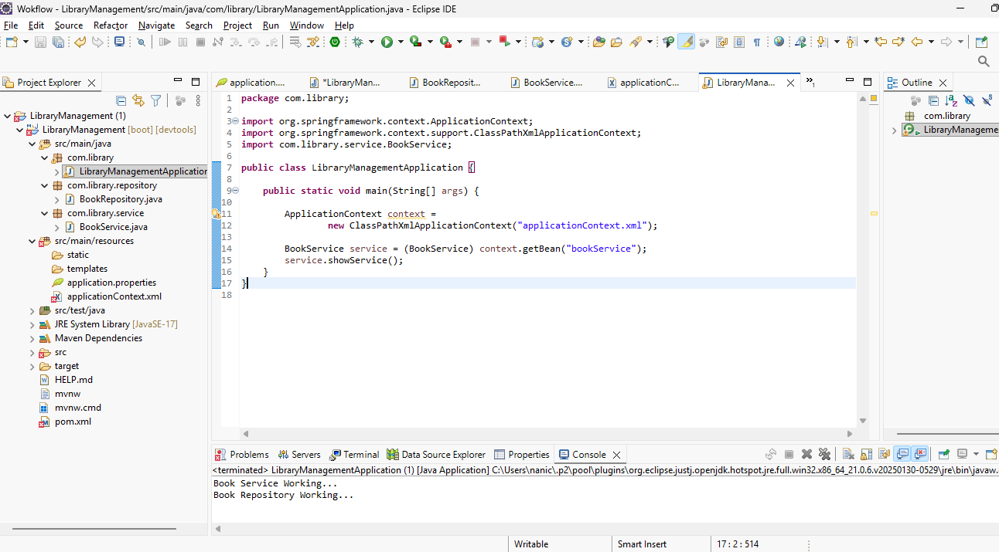
STEP -4
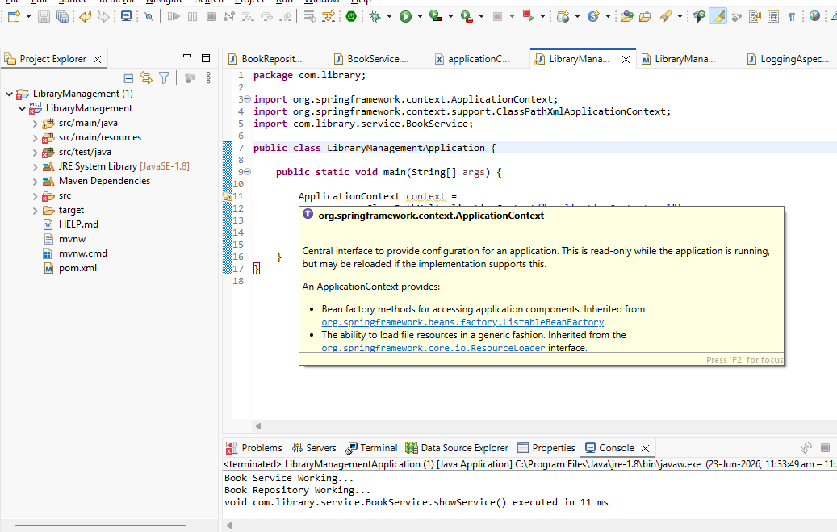
STEP -5
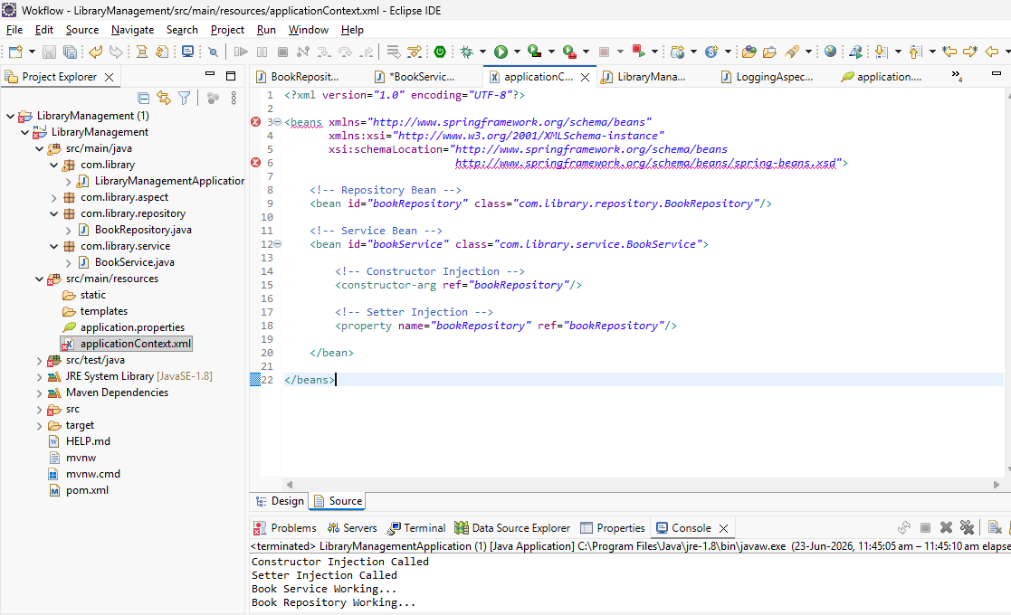
STEP – 6 DEFAULT CONSTRUCTOR


